**Packages**   
Classes and interfaces 🡪 After compiling it is stored in the form of files.

How to organize these different files??  
1) We will create a folder, and put the files related to that folder.

Packages are folders

## **How to import packages ???**

## **Method-1**

1. Importing java package.
2. Importing lang package.
3. In than lang package, importing all the classes

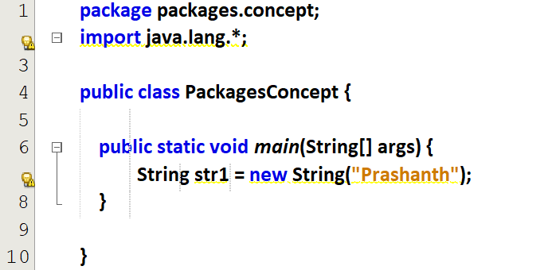 **Method-2**If suppose I don’t need all the classes, I can import specific class.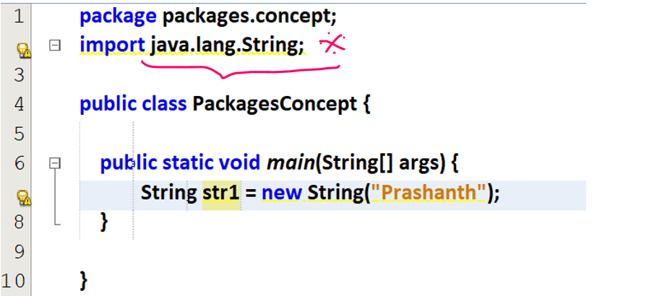



## **Method-3**

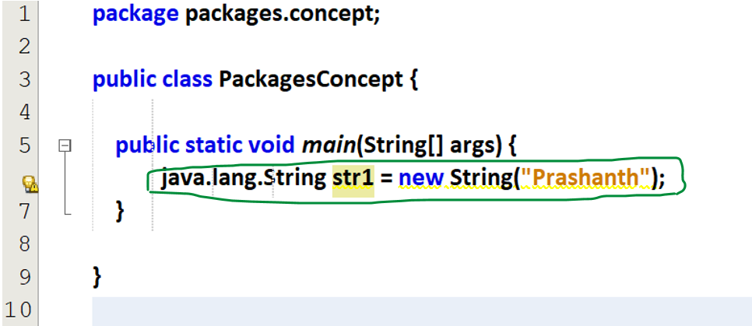

## **Creating Packages**

**Method-1**While a creating a new Java-project, automatically JDK will set up a package same as the project name.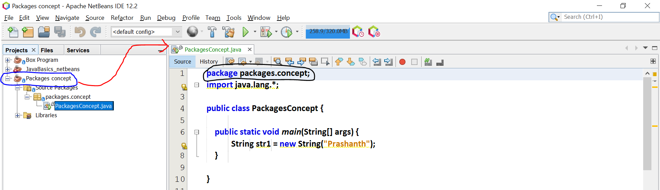

**Method-2**Creating our own package.

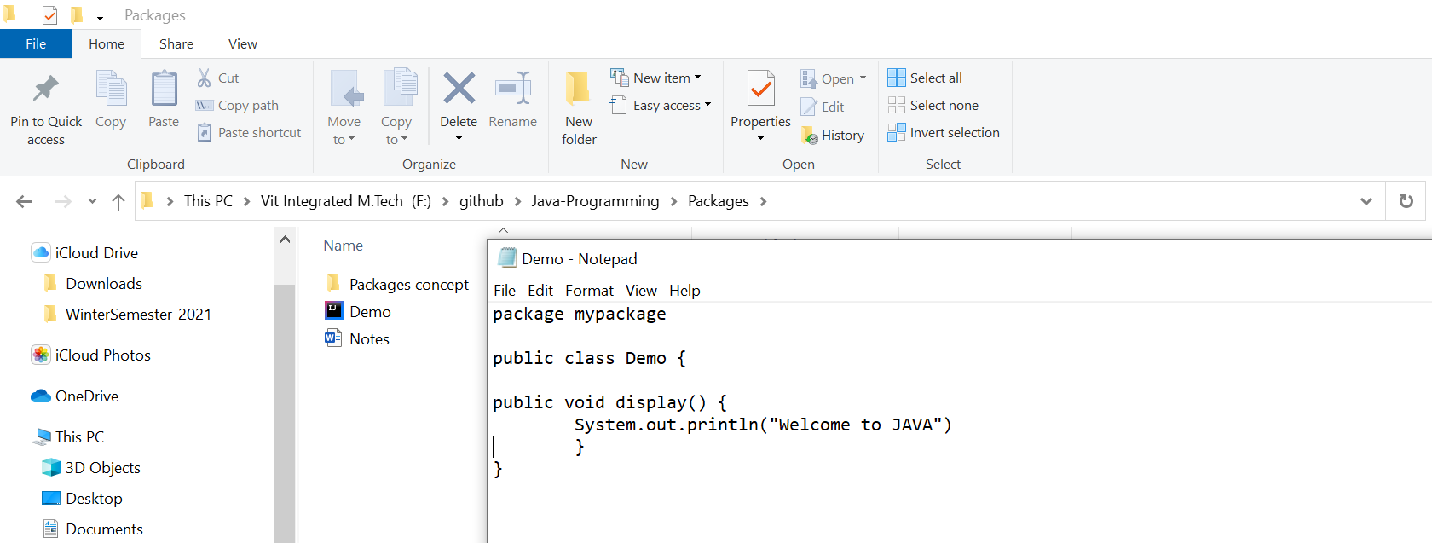Creating a JAVA class Demo which belongs to the package my-package.

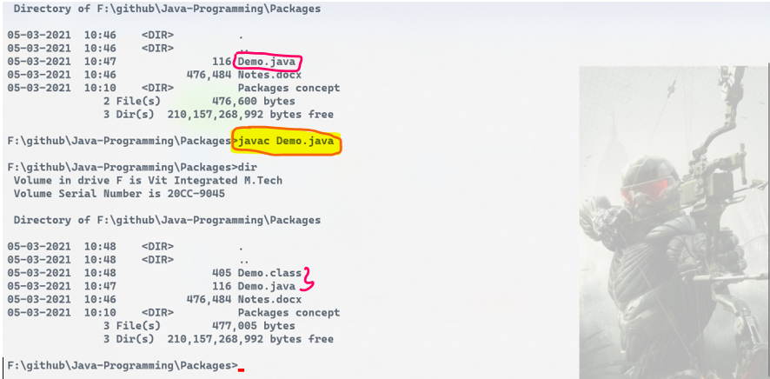

Now Demo.class file is created, indicating that Demo.java is compiled successfully. But package is not created.

Compiling the JAVA file along with package.

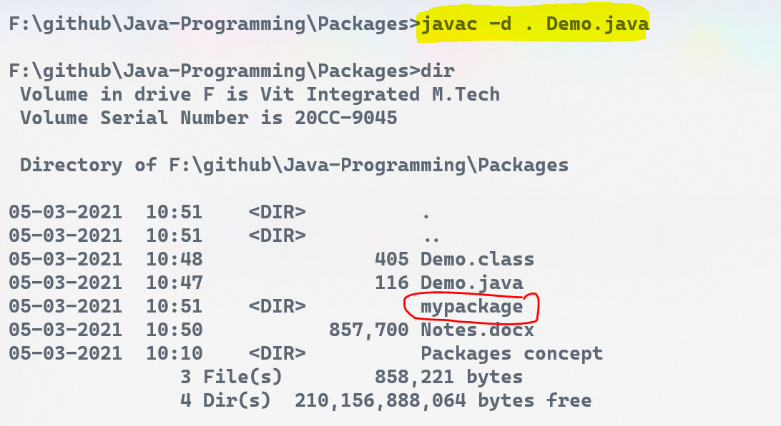  
Going inside the package folder

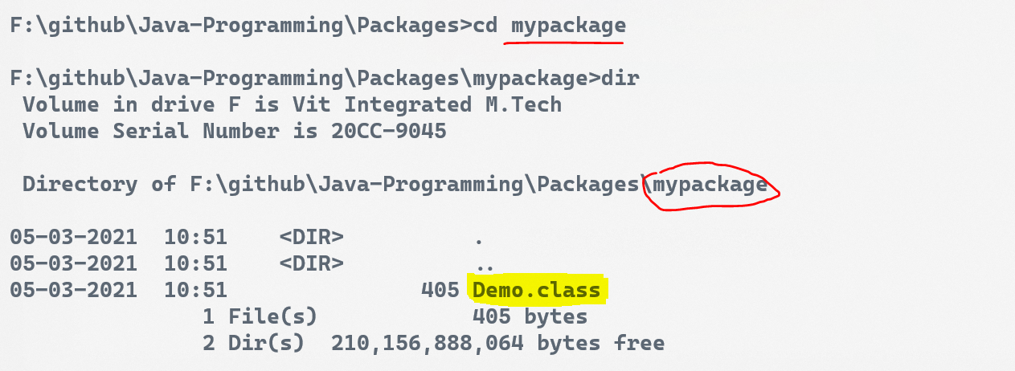

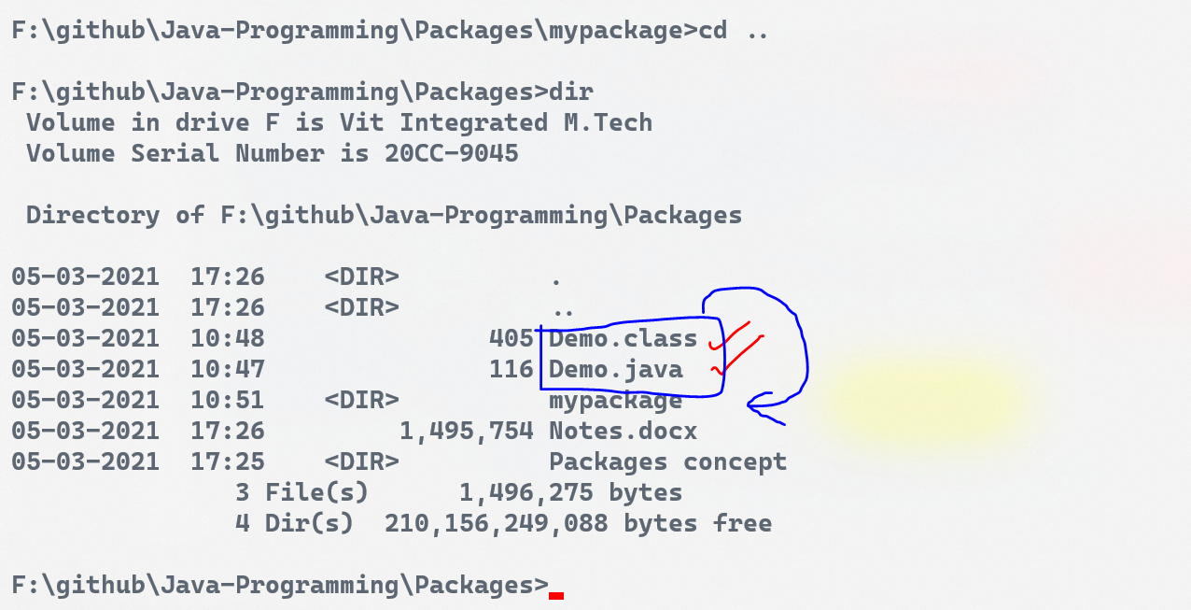

I want Demo.java and Demo.class in mypackage folder, but the 2 files are outside mypackage folder.

Deleting the class files

Once again saving the Demo.java file inside the package **mypackage**

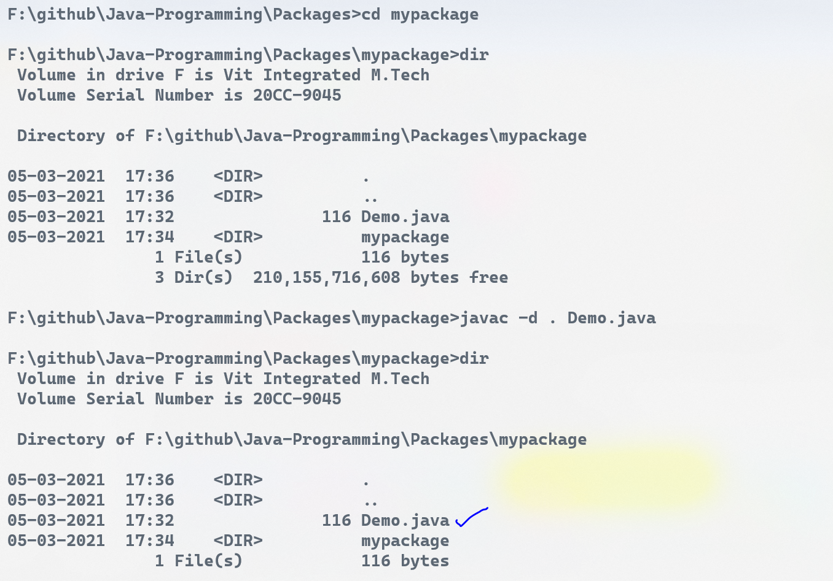

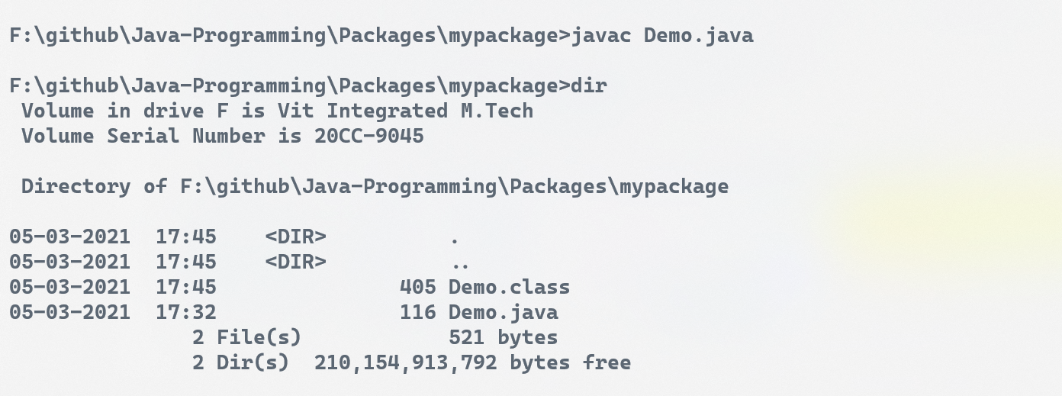



javac Demo.java 🡪 to compile only Demo.java, so Demo.class file is created.  
javac -d . Demo.java 🡪 to compile Demo.java file, so that the package is also created.

## ***How to create another class in a package?***

Saving Demo2.java file inside the package **mypackage**, and then compiling it.

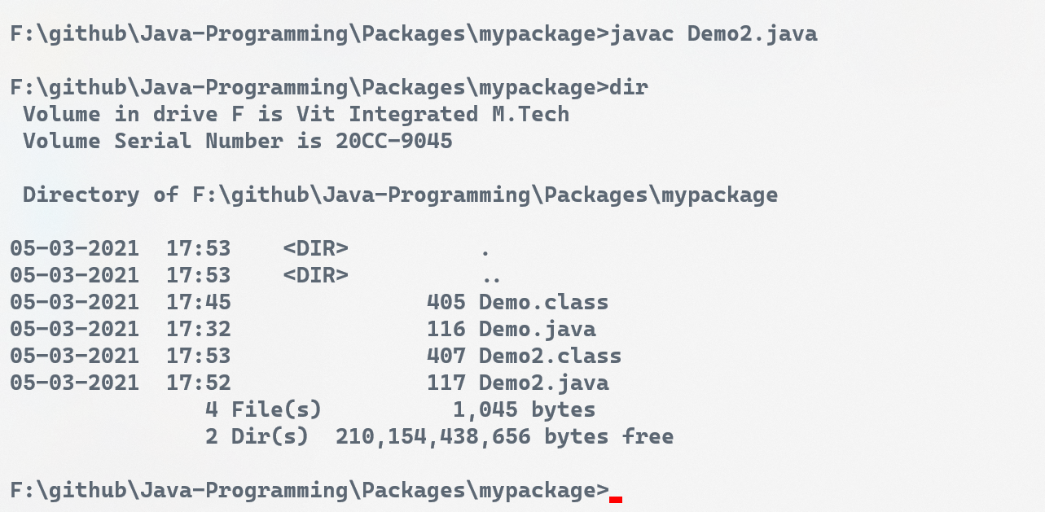

## ***How to create a package class within a package?***

Creating Demo3.java file inside the mypackage

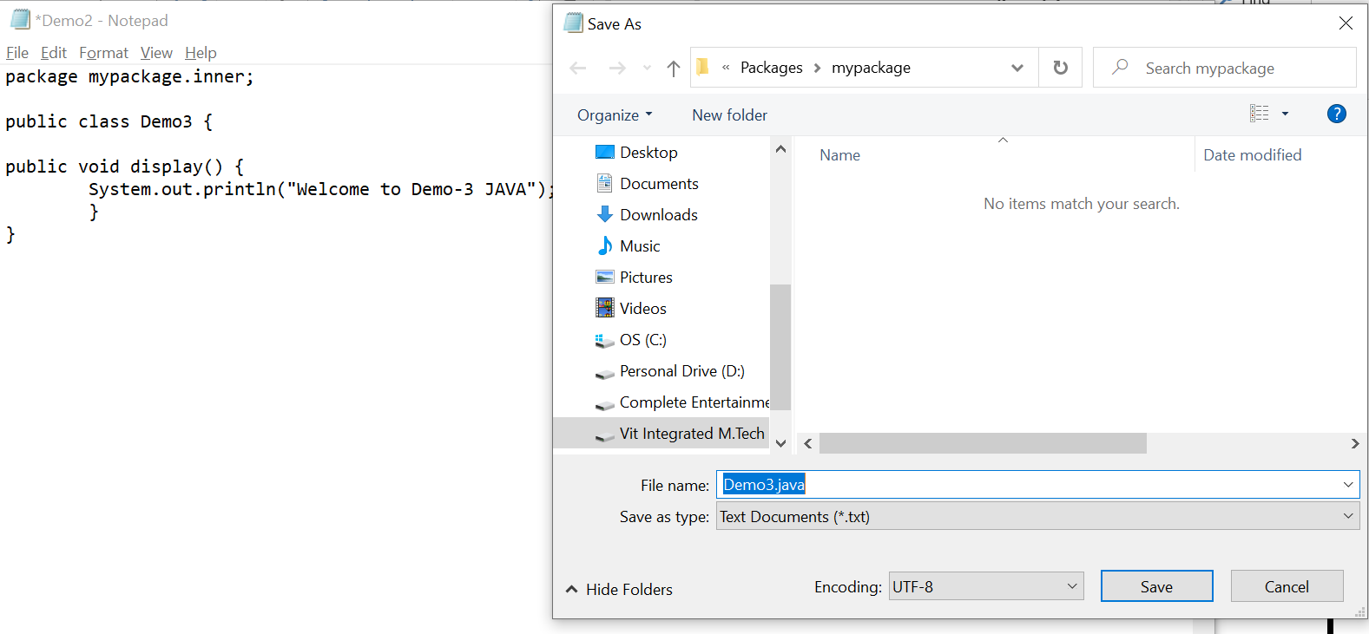



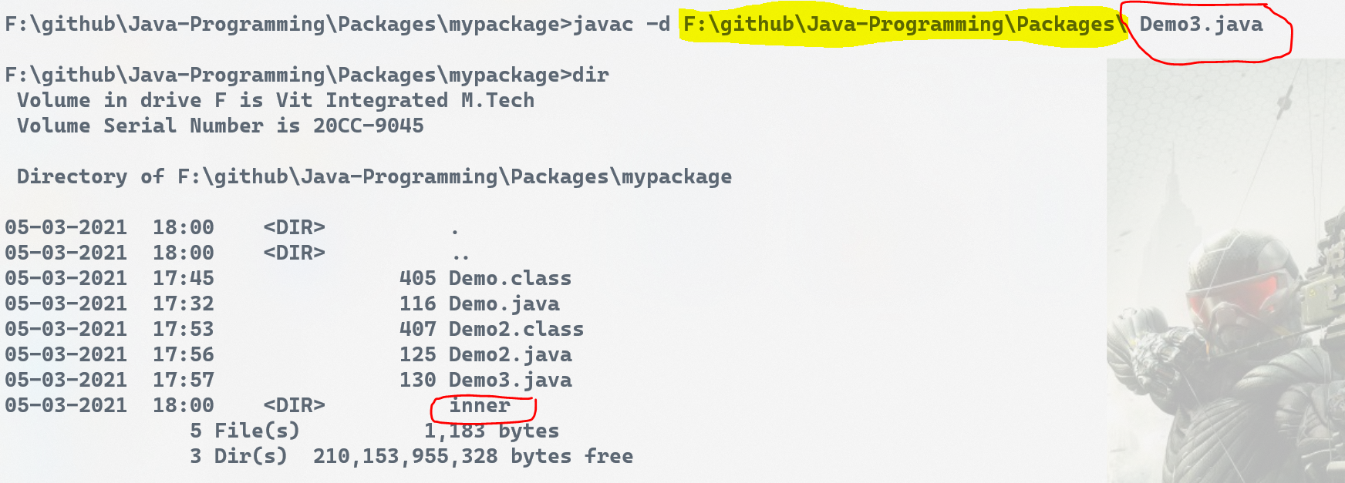

Compiling Demo3.java file, so that **inner** package is created,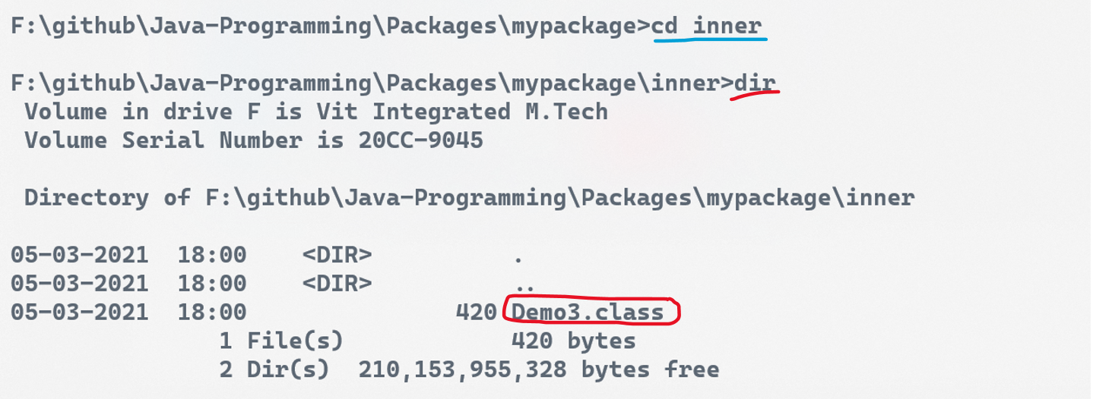

Inside that inner package, Demo3.class is available

# Creating a new Java file, and using **mypackage** java files

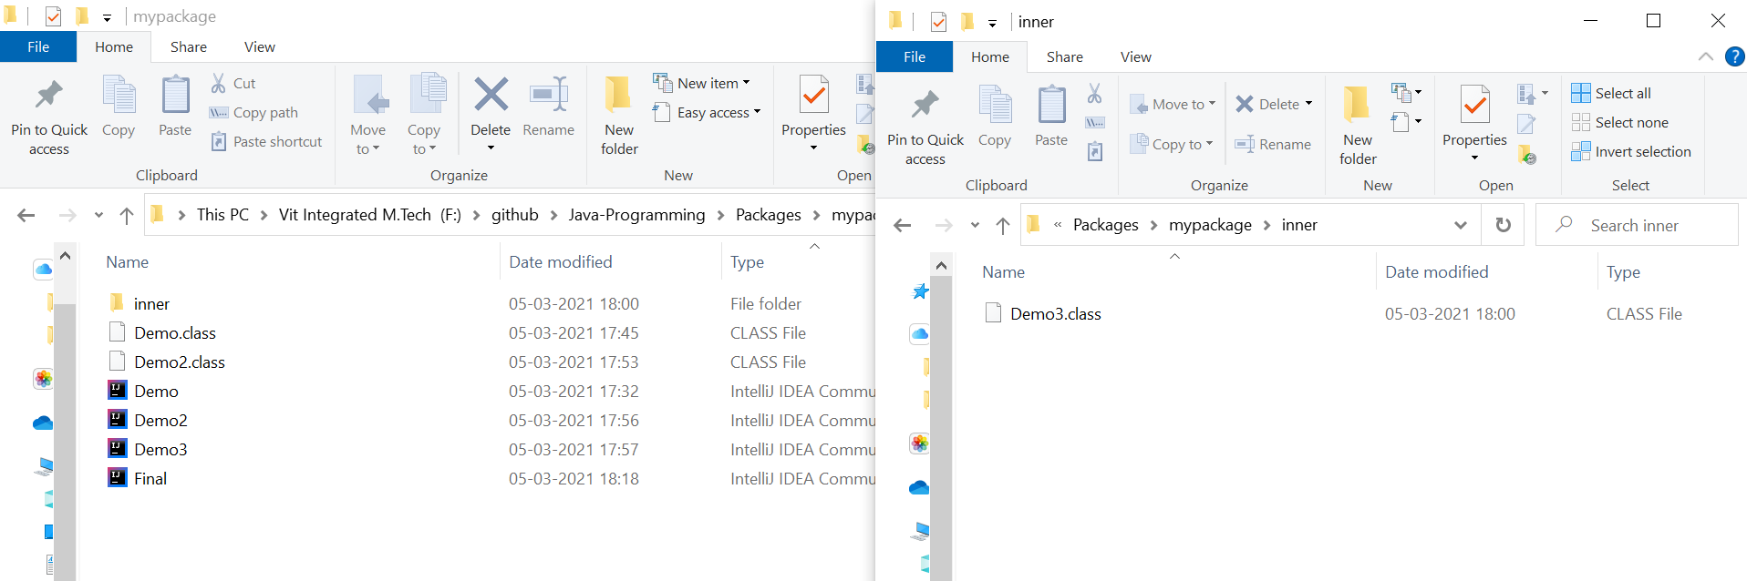

Final.java is created. To access the package files   
<file_name>.java is not important, <file_name>.class is only important.

